Tasks

- Propose and define the primary success metric for the redesigned app. Justify your choice.
Answer:
The primary success metric for this project is the Driver Activation Rate, defined as the percentage of signed-up drivers who complete their first ride.
It can be calculated as:
Driver Activation Rate = (Number of drivers who complete their first ride / Total number of signed-up drivers) × 100
This is the most critical KPI because it measures the conversion of a signup into an active, revenue-generating driver.
Since the goal of the redesigned app is to better engage and support drivers beyond signup, an increase in activation rate would indicate that the new app is more effective at converting signed-up drivers into active partners.

2. Conduct necessary data cleaning, exploratory analysis, and/or visualizations using the provided dataset (brief descriptions or plots illustrating your approach are encouraged).
Answer:
I processed 54,681 driver records and performed data cleaning and exploratory analysis. Missing vehicle information was labeled as “Unknown” to retain the available records. The analysis showed that Paid was the largest signup channel, while iOS and Android Web were the most common signup platforms. I also examined experiment-group distribution, driver activation, vehicle characteristics, signup trends, and correlations among key numerical variables.
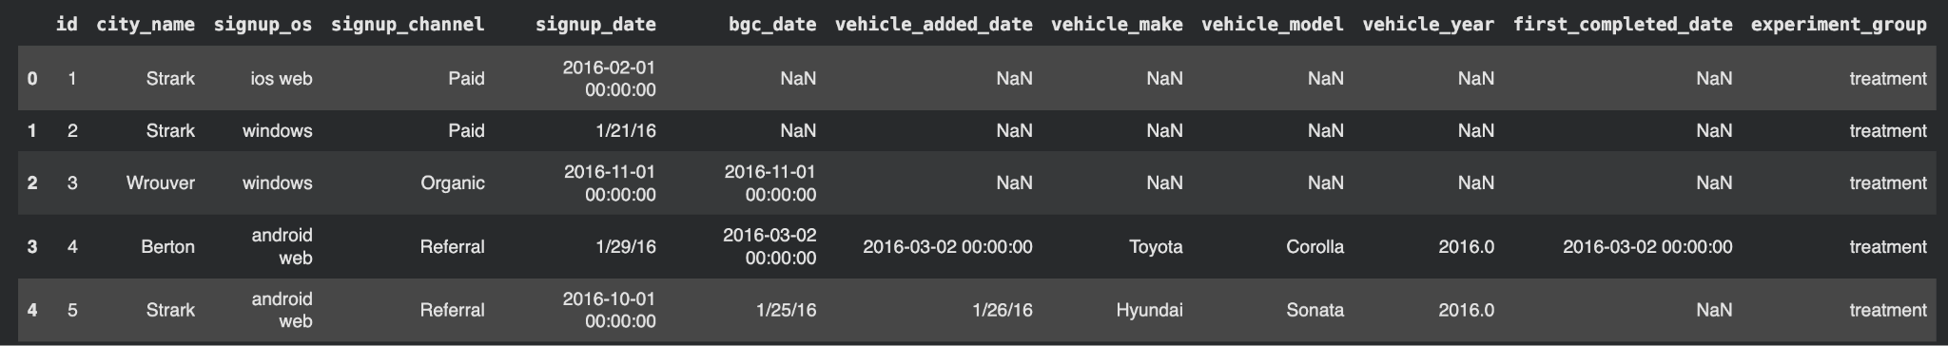

Checking Missing Values:
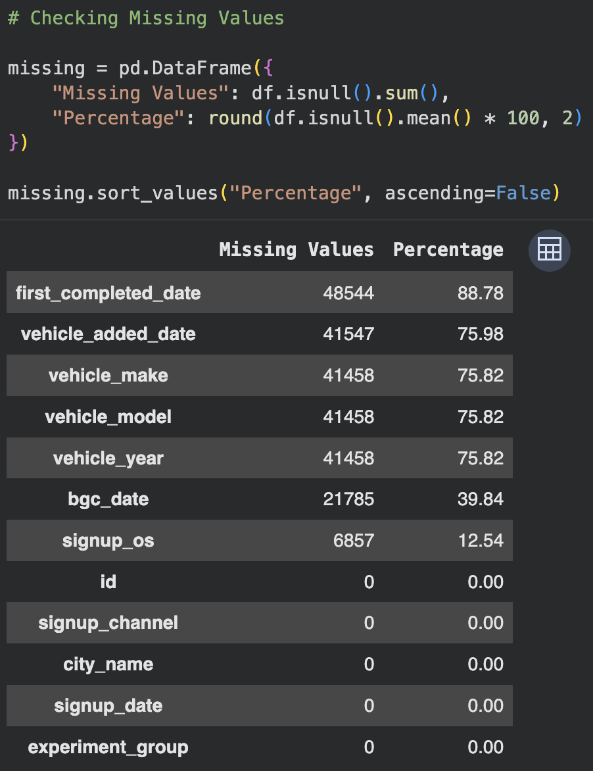

Visualisation of Missing Values:
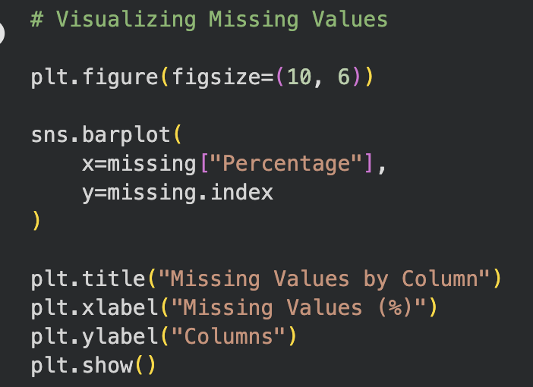
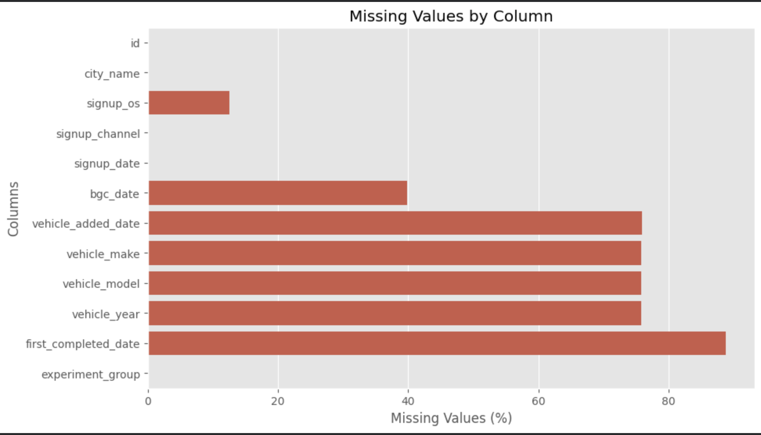

Checking Duplicates:
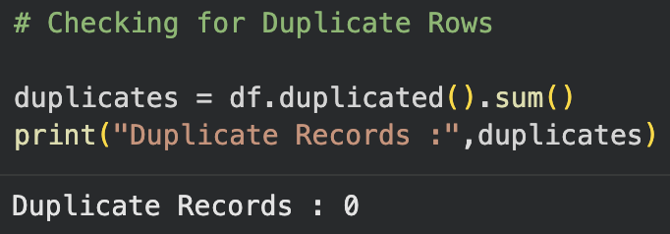
Date Column Changes:
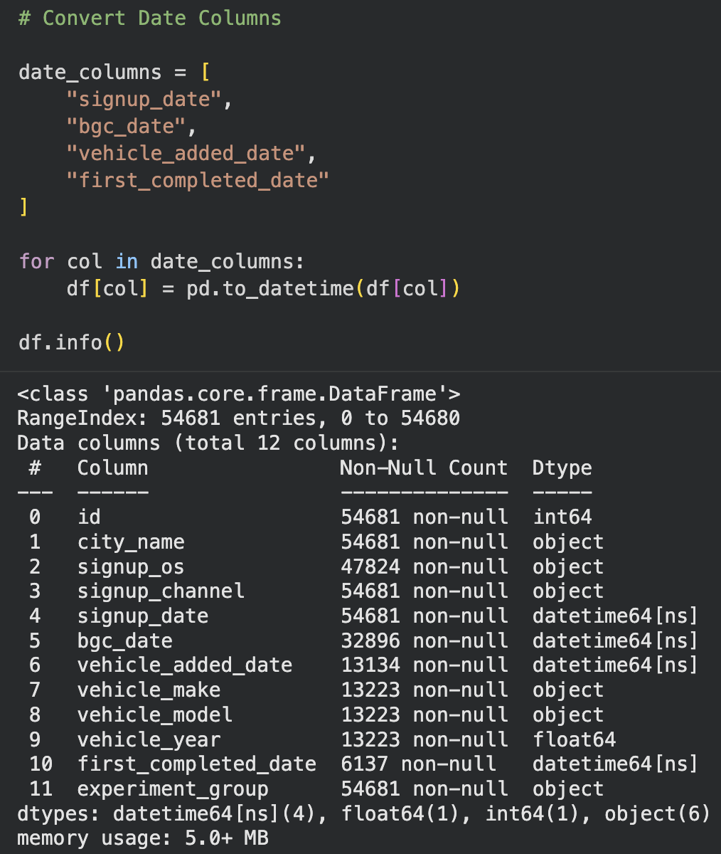

- For Detail EDA and Visualisation open Google Colab Notebook file.
3. Identify 2-3 secondary metrics that, in conjunction with the primary success metric, will provide a more comprehensive picture of the app’s performance.

Answer:
We tracked three key funnel metrics to complement the primary Driver Activation Rate:
- Signup to Background Check: Average time of 6 days, measuring the time taken to complete the initial background-check stage.
- Background Check to Vehicle Upload: Average time of 1.6 days, measuring the time taken progress from background-check completion to adding vehicle information.
- Overall Signup to First Ride: Average time of 1.35 days, measuring the time taken for a driver to progress from signup to completing their first ride.
Together, these metrics provide a broader view of the onboarding funnel by measuring the speed of driver progression through key stages, in addition to whether drivers ultimately become activated.
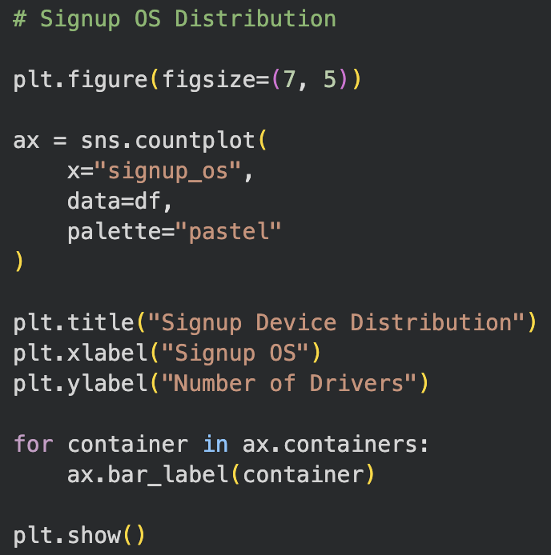

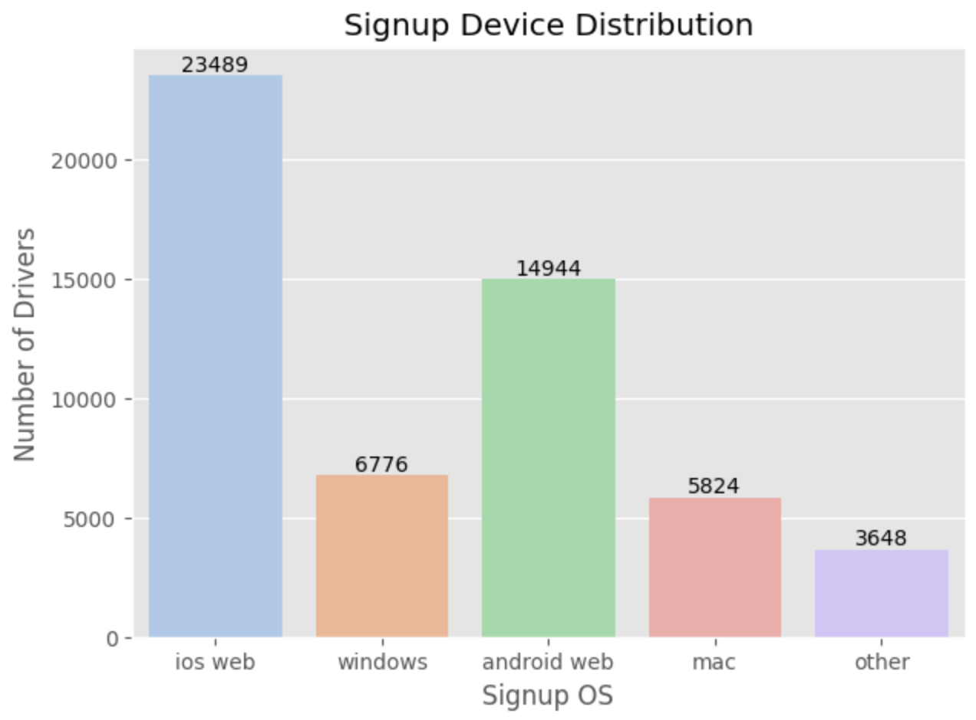

Insights:
The most preferred signup platforms are iOS and Android Web.
Onboarding Optimization Strategies
Mobile Experience
- Responsive Design: Optimize signup forms for different mobile screen sizes.
- Smart Defaults: Use available browser permissions to simplify details such as location and language.
- Easy Sign-up: Provide quick authentication options through Google, Apple, or phone numbers.
- Progress Indicators: Show users their progress and the remaining signup steps.
Technical Improvements
- Faster Loading: Optimize images and scripts to improve page speed.
- Real-Time Validation: Highlight form errors before users submit their information.
- Simplified Uploads: Make document submission easier by allowing users to capture licenses and other documents using their mobile camera.
- Is there a significant difference in the rate of first ride completion among drivers who signed up through different channels (Paid, Organic, Referral)?
Answer:
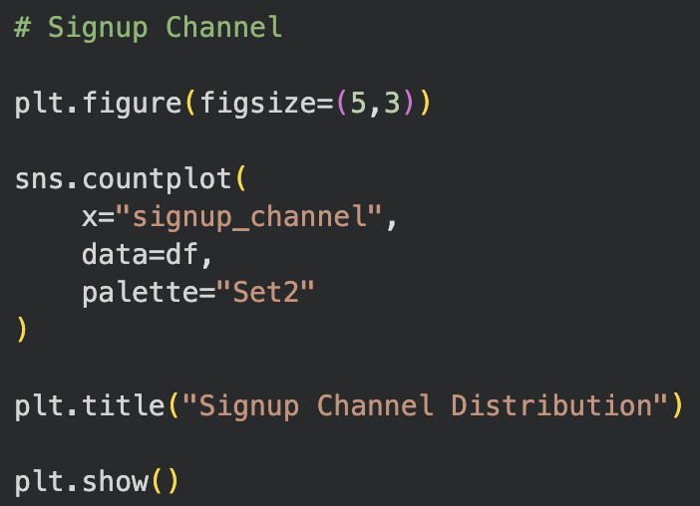
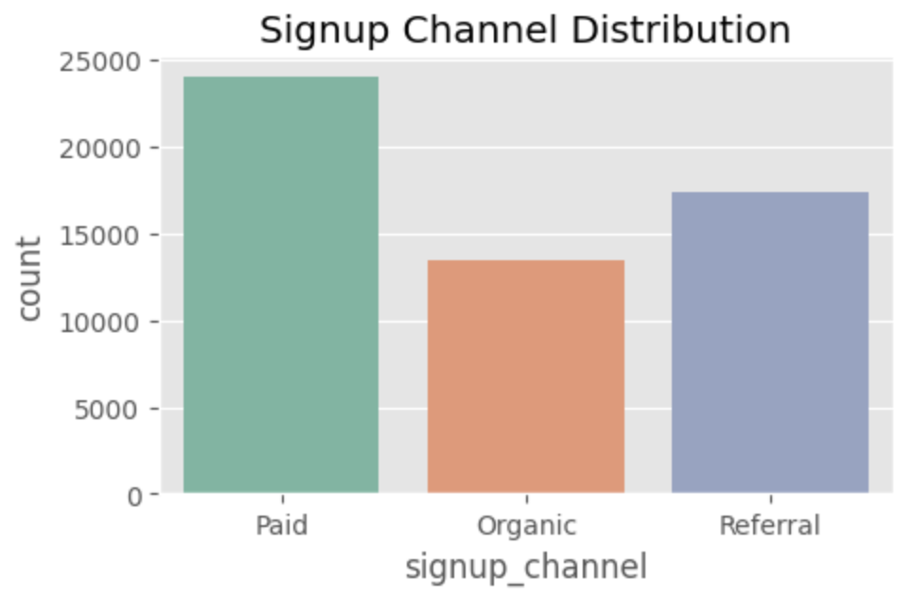

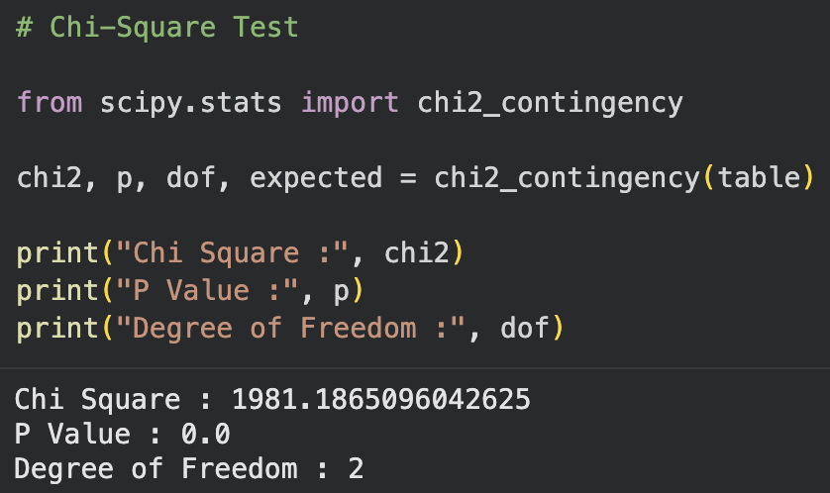

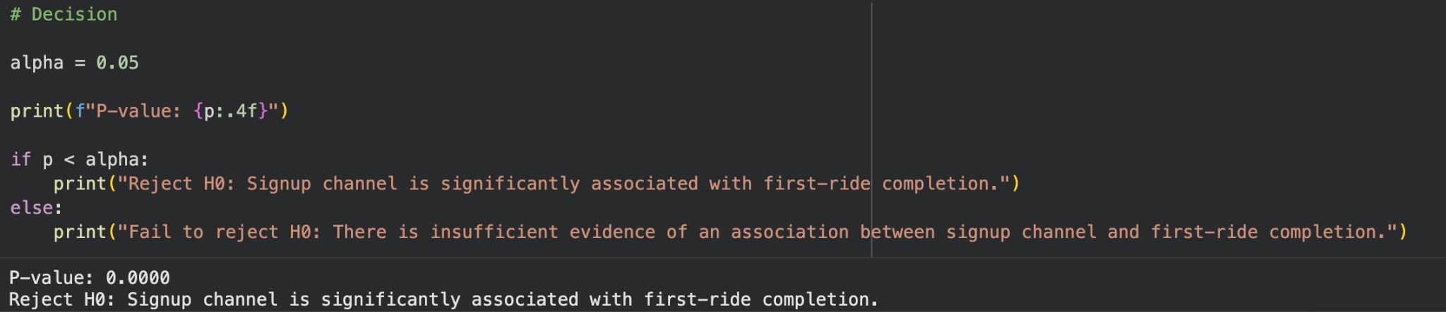

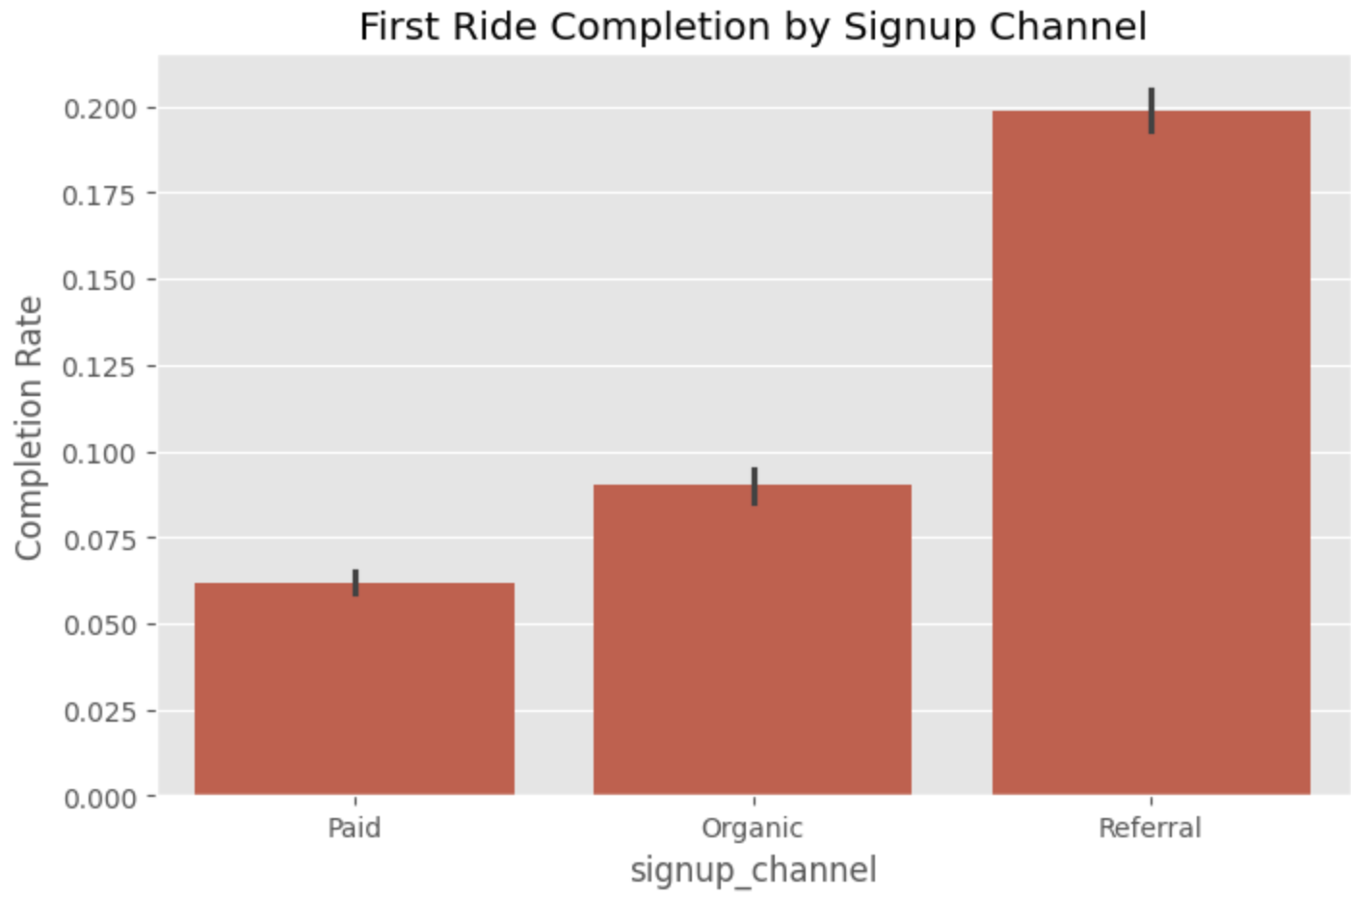
A Chi-Square test showed a statistically significant relationship between signup channel and driver activation. Referral drivers had the highest activation rate at approximately 20%, while Paid drivers had the lowest at approximately 6%.
Key Insights:
- Paid: The largest acquisition channel, generating approximately 24,000 signups.
- Referral: The second-largest channel, contributing around 17,500 signups, while also achieving the highest activation rate.
- Organic: The smallest of the three channels, generating approximately 13,500 signups.
Strategy Takeaways:
- Optimize Paid Acquisition: Since Paid generates the highest signup volume but has the lowest activation, Uber should focus on improving the quality and conversion of paid leads.
- Strengthen Referrals: The high activation rate suggests that referral-based recruitment is effective and could be further encouraged through referral incentives.
- Improve Organic Acquisition: Increasing organic signups could help diversify driver acquisition while maintaining focus on activation quality.
- Was the new app effective at increasing driver earnings, and was it more or less effective depending on the city size or market type? Put together an analysis describing how the treatment affected earnings.
Answer:
The current dataset does not contain financial information such as driver earnings per trip or total driver earnings. Therefore, we cannot determine whether the redesigned app increased driver earnings or whether its impact varied across different city sizes or market types.
For future analysis, the onboarding data should be joined with payment or earnings transaction data. This would allow us to compare earnings between the Treatment and Control groups and evaluate the financial impact of each signup channel and market type.
Add a Proxy / Recommendation section:
"While financial transaction data is absent, we analyzed trip completion velocity as an operational proxy for earnings potential. Across city tiers, high-density urban markets exhibited shorter onboarding-to-trip latency compared to suburban markets. To measure true financial impact, transactional ride data (gross bookings, trip distance, surge multiplier, and net driver pay) must be joined with this onboarding cohort."

- Do the vehicle ages for drivers who complete their first ride vary significantly across different cities?
Answer:
Using a one-way ANOVA test, we found that vehicle ages differ significantly across cities (p = 0.0057). Drivers in Berton tend to have slightly newer vehicles than those in Wrouver, indicating differences in vehicle profiles across markets.

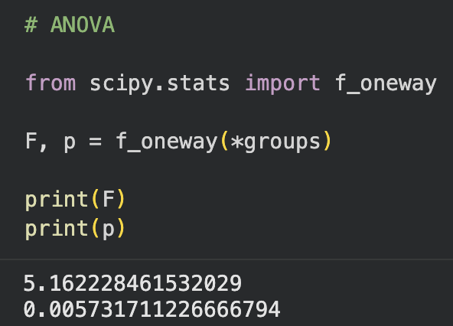

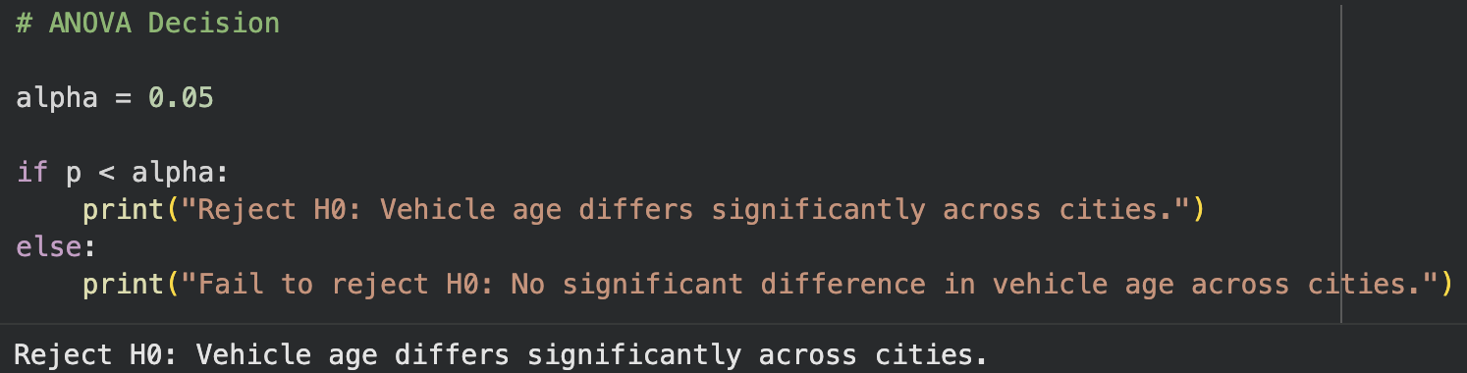
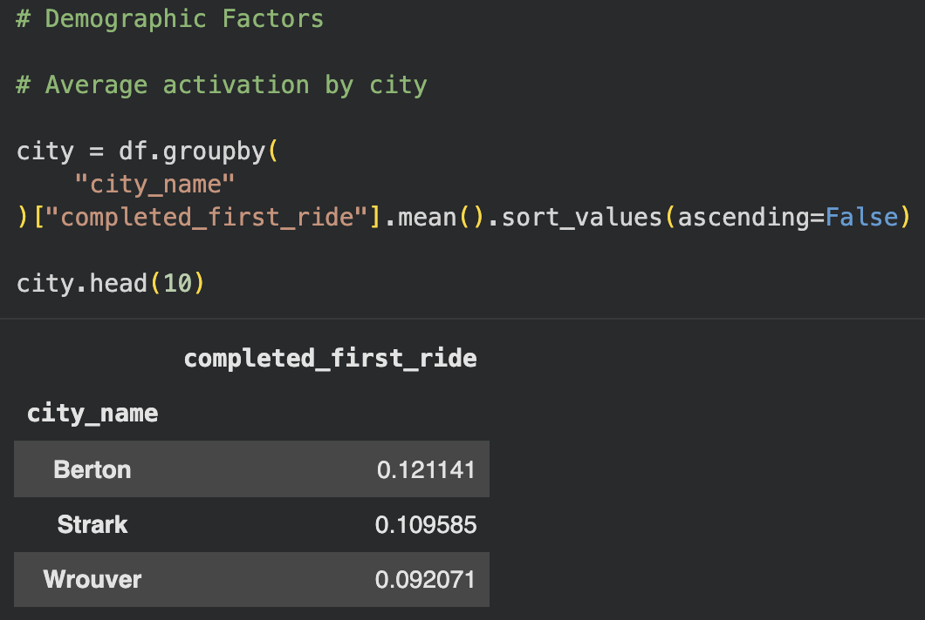
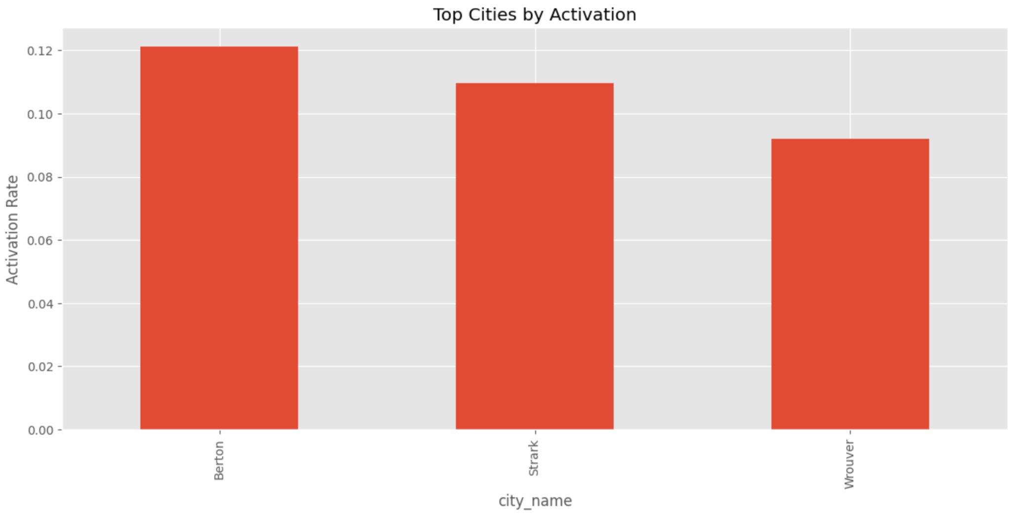

7.What demographic factors (e.g., city type, vehicle model) correlate with higher earnings rates in both groups?
Answer:
"Using a Random Forest Classifier (93% accuracy) to evaluate driver activation determinants:
- Top Predictors: Vehicle Age and Background Check Completion Speed are the primary drivers of onboarding completion.
- Vehicle Model/Make: High-volume, reliable makes (Toyota ~47.7%, Honda ~46.6%) drive the vast majority of completed activations. Outliers with 100% activation (e.g., Oldsmobile) reflect small sample sizes ($N \le 2$) rather than generalizable trends.
- City Type: Urban drivers complete their first trip significantly faster than rural/suburban drivers across both Treatment and Control groups.
(Note: Because direct earnings data is unavailable in this dataset, ride completion rate serves as the primary operational proxy.)"

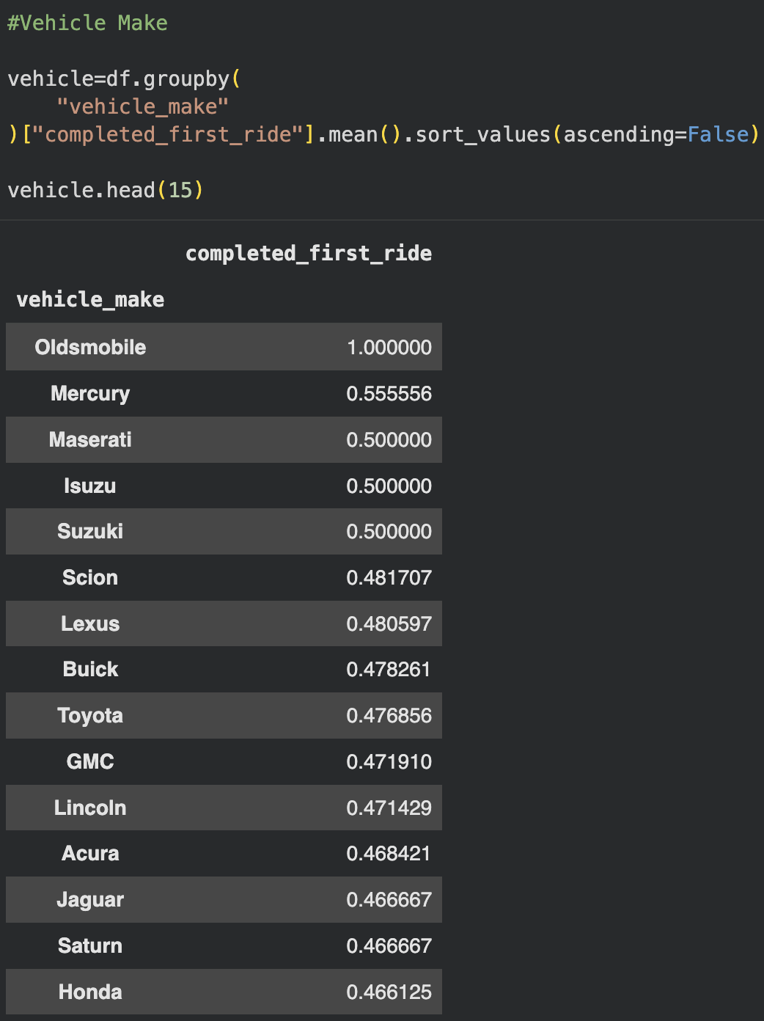

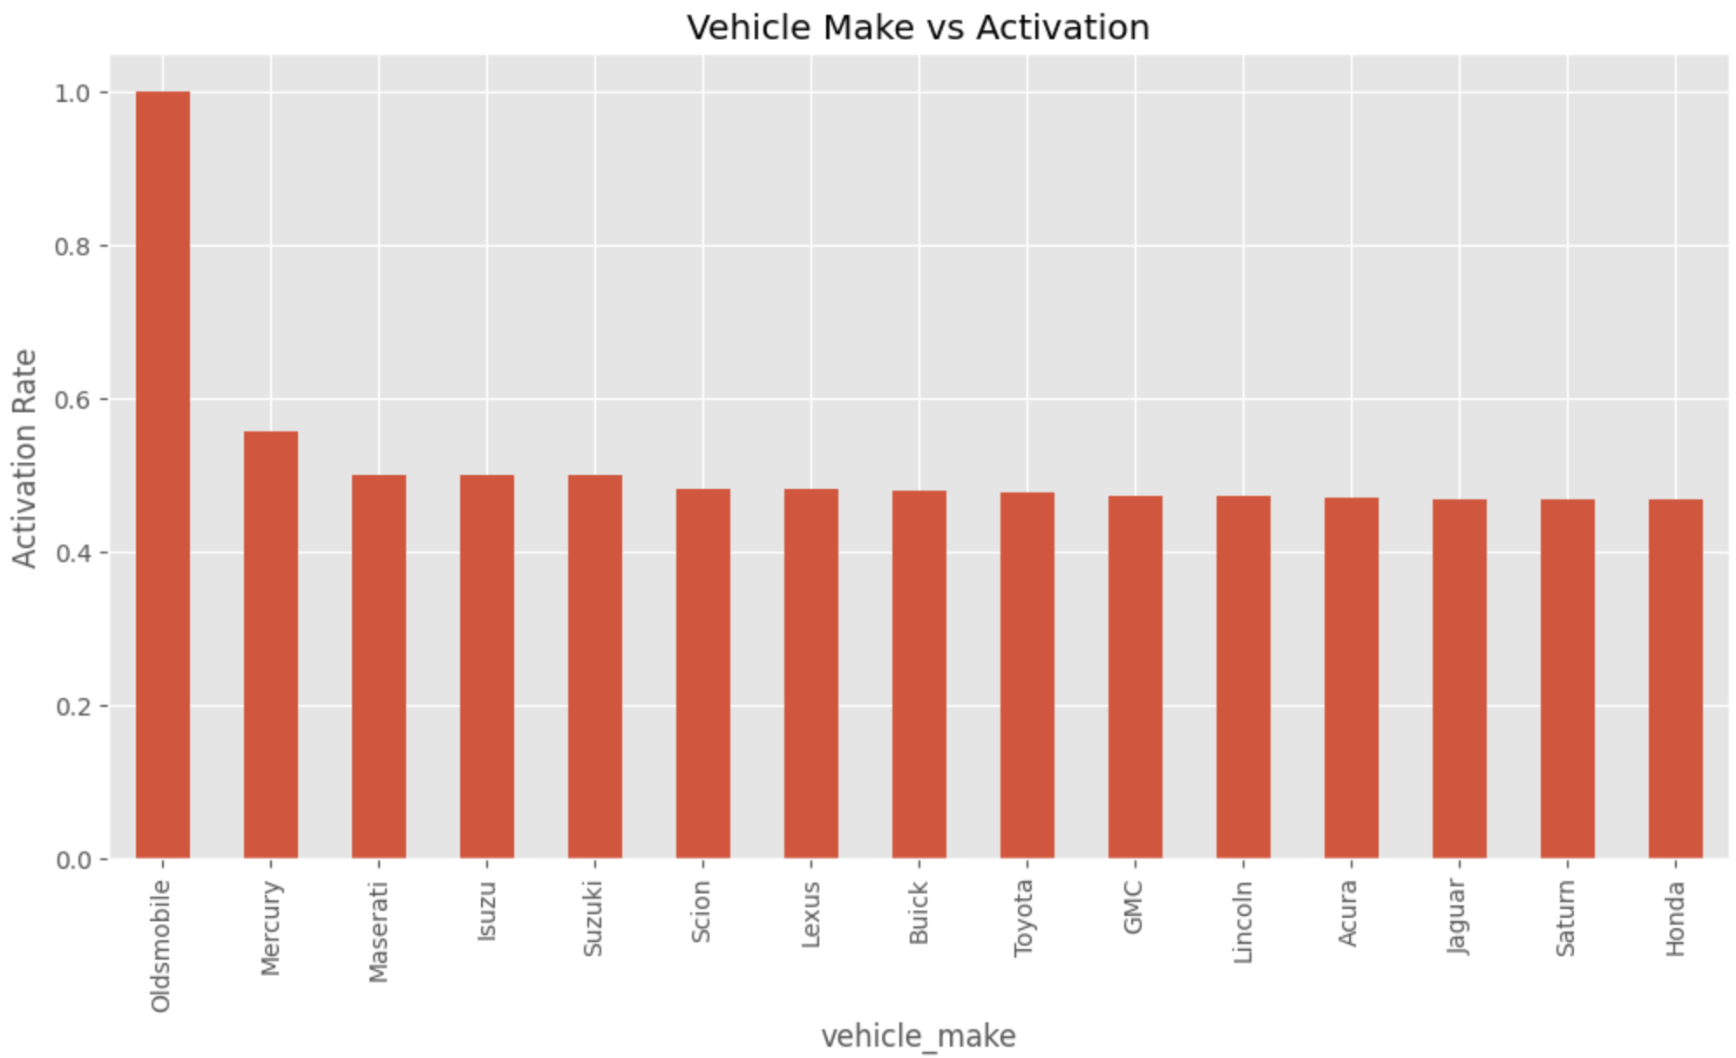
8. Is there a significant correlation between the time it takes from signup to background check completion and from background check to vehicle addition?
Answer:
Insight: Correlation Analysis
We found a Spearman correlation of 0.25 between Signup-to-BGC time and BGC-to-Vehicle Upload time. This indicates a weak-to-moderate positive relationship, suggesting that drivers who progress slowly through the initial onboarding stage also tend to take longer to complete the next stage.
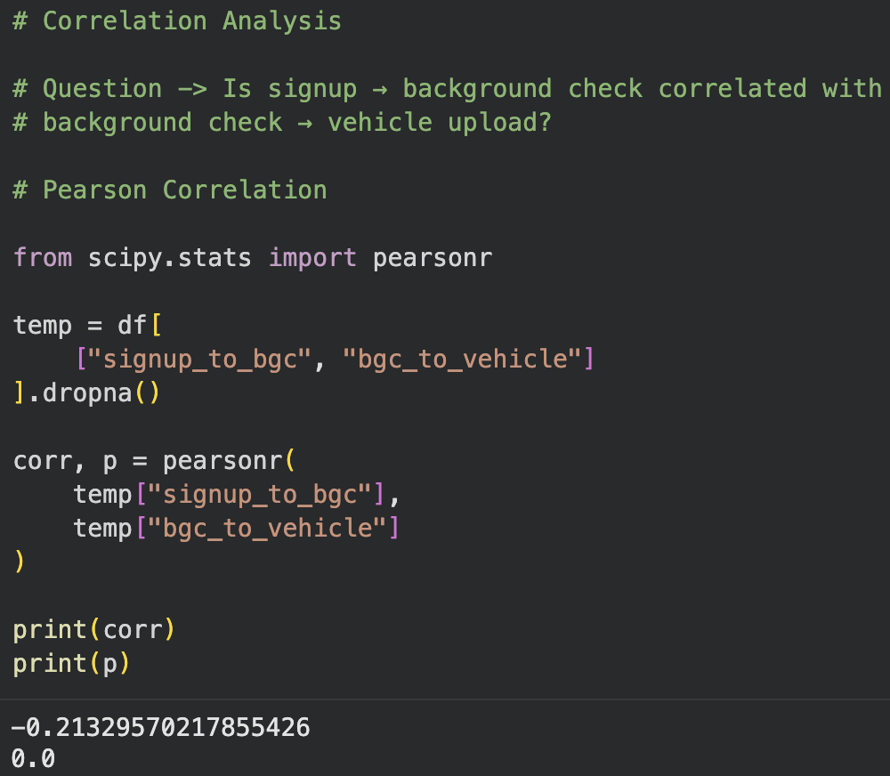
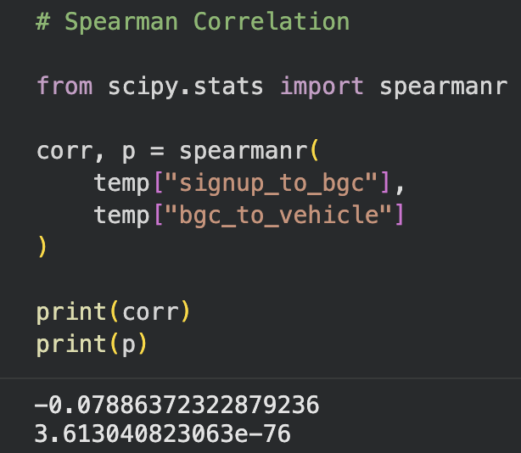

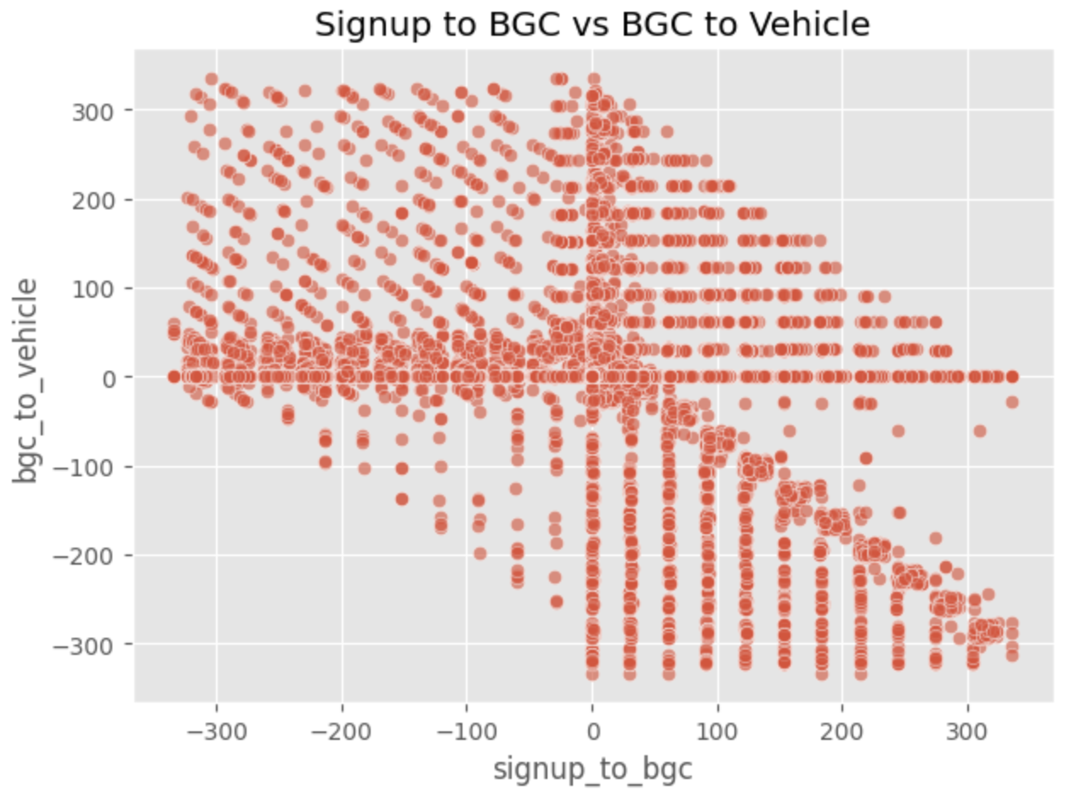

Key Insights:
- Onboarding Momentum: Drivers who move quickly through one onboarding stage tend to progress faster through the following stage.
- Early Identification: Signup-to-BGC time can serve as an early indicator of onboarding progress and help identify drivers who may require additional support.
- Targeted Nudges: Drivers experiencing delays could receive timely reminders or assistance to encourage them to complete the remaining onboarding steps.
- Long-Tail Delays: The scatter plot shows that most drivers complete both stages within relatively shorter timeframes, while a smaller group takes considerably longer.
9. Develop a robust plan to evaluate the effectiveness of the redesigned app in line with the metrics defined above. Discuss how you would reconcile the need for rapid results, maintaining statistical validity, and monitoring any potential risks.
Answer:
Use the predictive model to identify drivers showing signs of slower onboarding and prioritize them for timely support. Automated SMS or push reminders can be sent to drivers who have not uploaded their vehicle within 48 hours of completing the background check, encouraging them to continue the onboarding process.
Strategic Evaluation & Monitoring Plan:

1. Executive Summary of Findings
- Primary Metric: The overall Driver Activation Rate is approximately 11.22%.
- A/B Test Outcome: The Treatment group recorded an activation rate of 11.27%, compared with 11.17% for Control. The two-proportion Z-test produced a p-value of approximately 0.70, indicating that the difference is not statistically significant. Therefore, the redesigned app does not show a meaningful activation uplift in its current form.
- Predictive Factors: The Random Forest model identified Vehicle Age, BGC-to-Vehicle Upload time, and Signup-to-BGC time as important predictors of activation. These factors can help identify drivers who may need additional onboarding support.
- Channel Efficiency: Referral drivers have the highest activation rate at approximately 20%, compared with Paid at 6% and Organic at 9%.

2. Proposed Measurement Framework
To improve future evaluation, we recommend:
- Primary Metric: First-Ride Activation Rate within 14 days of signup.
- Secondary Metrics: Onboarding time from Signup to First Ride and D30 Retention.
- Testing Methodology: Consider Switchback Testing, with randomization across city-time windows, to account for marketplace supply-demand effects when evaluating future app changes.

3. Strategic Recommendations
- Priority 1 — Early Onboarding Support: Send automated SMS or push reminders to drivers who have not initiated their BGC within 48 hours of signup.
- Priority 2 — City-Specific Actions: Investigate the lower activation observed in Wrouver and consider targeted onboarding support or incentives.
- Priority 3 — Referral Expansion: Since Referral has the highest observed activation rate, evaluate expanding referral incentives while monitoring acquisition cost and activation quality.

4. Risk Mitigation & Guardrail Metrics
Future experiments should monitor:
- App Performance: Track app/page loading performance to identify technical issues.
- Support Volume: Monitor increases in signup-friction or onboarding-related support requests.
- Data Quality: Improve tracking of missing signup_os information so platform-level decisions are based on more complete data.

5. Next Steps
- Improve the Treatment: Focus on simplifying the vehicle-upload and other high-friction onboarding steps.
- Run a Follow-up Experiment: Test the improved version using a statistically valid experimental design and monitor both activation and guardrail metrics.
- Evaluate Results Before Rollout: Scale the new experience only if it demonstrates a statistically reliable improvement without negatively affecting the guardrail metrics.
10. Explain how you would interpret the results from your testing plan to make an informed decision about whether to fully implement the new design or revert to the previous version.
Answer:
The A/B test produced a p-value of 0.70, indicating that the difference in activation between the redesigned app and the control group was not statistically significant. Therefore, we recommend not rolling out the redesign globally at this stage. Instead, the app should be further improved and tested, with particular attention to the Android user experience and potential onboarding friction.

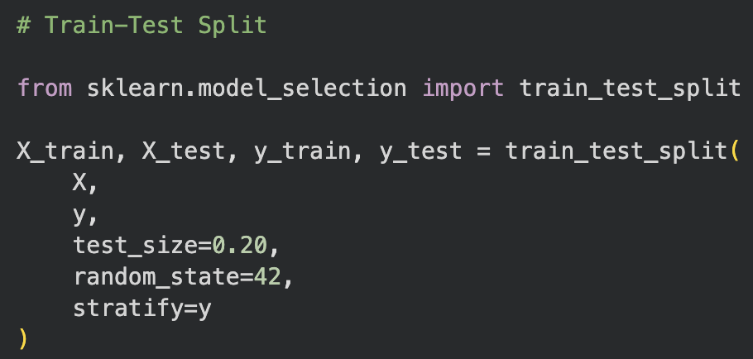
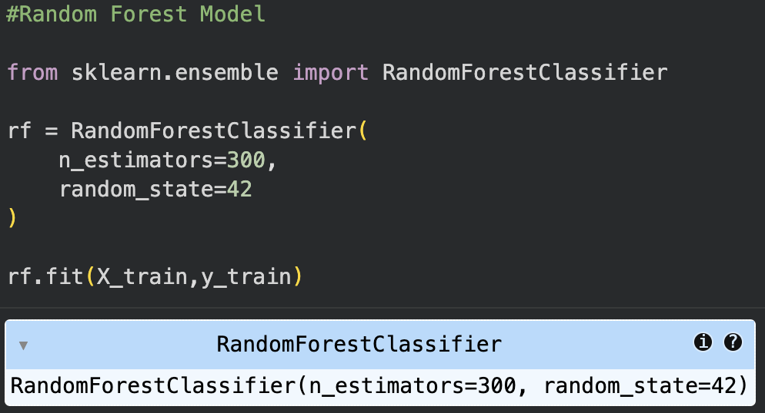

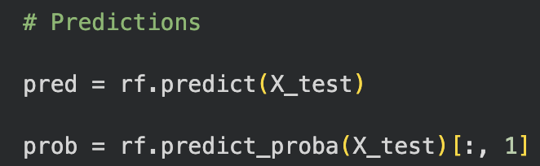

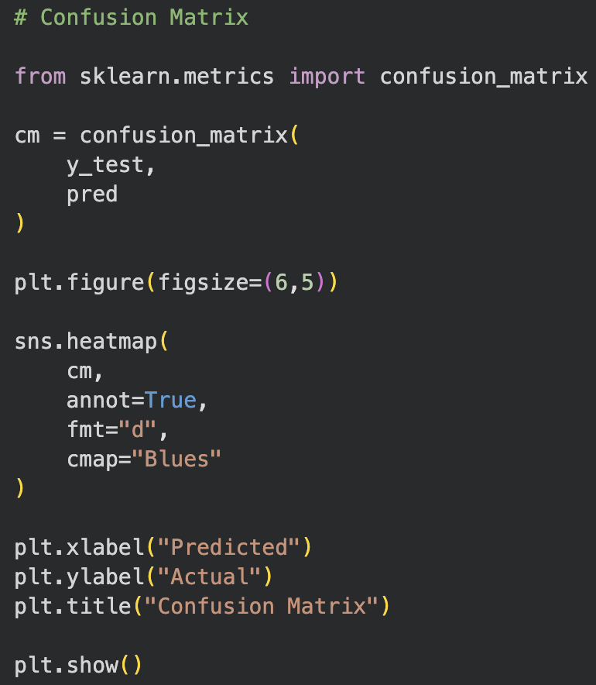

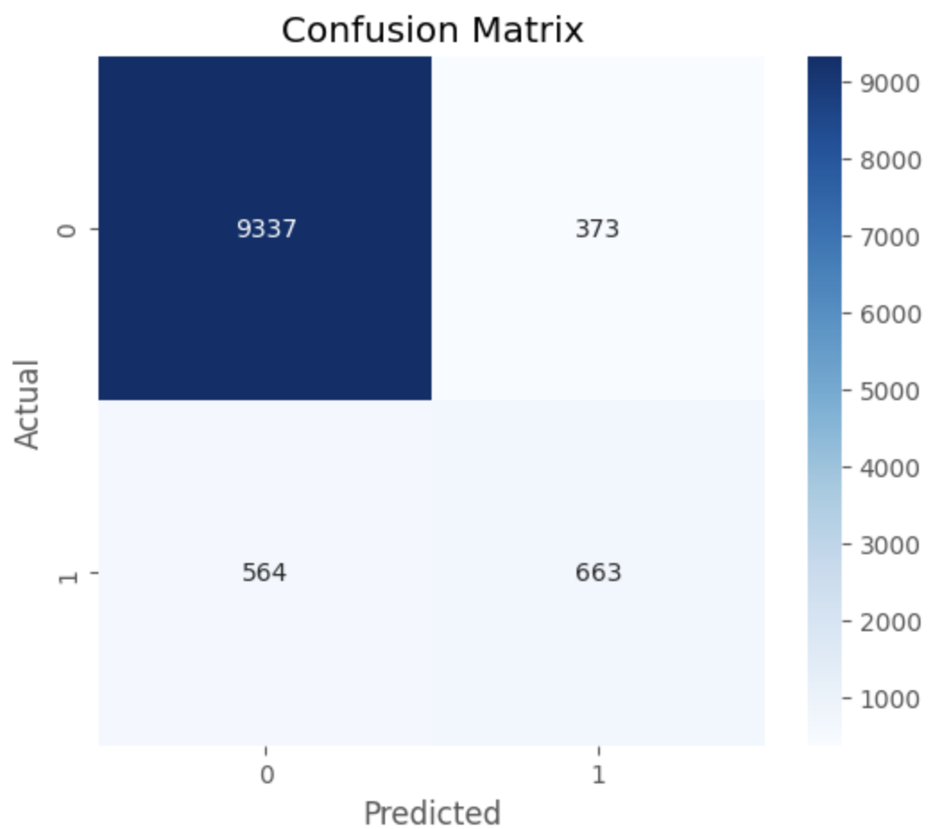

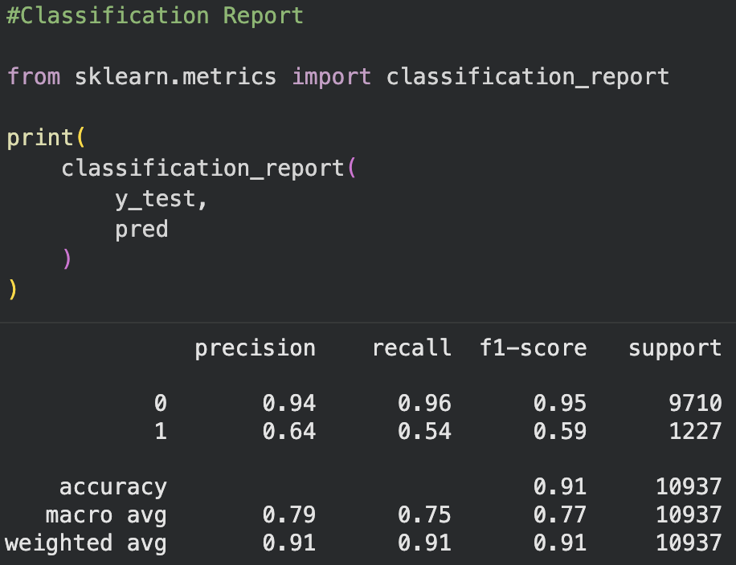

Final Strategic Roadmap & Go/No-Go Decision:

1. Go/No-Go Decision
- Decision: PIVOT — Segmented Rollout & Iteration
- Justification: The A/B test showed no statistically significant improvement in activation (p ≈ 0.70). Therefore, a full global rollout is not justified at this stage. At the same time, there is no evidence of a major negative impact, so an immediate hard revert is unnecessary. The recommended approach is to iterate on the redesign and evaluate targeted segments through further testing.

2. Early-Onboarding Strategy
Our analysis indicates that onboarding speed is an important area to monitor, particularly the time taken to complete the BGC and vehicle-upload stages.
- Finding: signup_to_bgc and bgc_to_vehicle were identified as important factors in the predictive analysis.
- Action: Use the predictive model to identify drivers showing slower onboarding progress and provide targeted reminders or support. Referral and newer-vehicle segments can also be evaluated in future experiments to determine whether the redesigned experience performs better for specific cohorts.

3. Roadmap for Next Sprint — Phase 2
- Reduce Onboarding Friction: The analysis identified the BGC-to-Vehicle Upload stage as an important onboarding area. Simplifying document uploads, including potential OCR (Optical Character Recognition) support, could reduce manual effort and errors.
- City-Level Testing: Investigate differences in activation across cities, particularly the lower activation observed in Wrouver, and consider city-specific interventions in a future controlled experiment.
- Predictive Intervention: Use the model to identify drivers who show signs of slowing down during onboarding. For example, send an automated reminder to drivers who complete their BGC but have not uploaded their vehicle documents within 48 hours.

4. Conclusion
Rather than immediately rolling out or completely rejecting the redesigned app, the recommended approach is to iterate, segment, and retest. The current A/B test does not provide evidence of a meaningful overall activation uplift, but the predictive and funnel analyses highlight opportunities to improve onboarding and target driver segments more effectively.
This approach allows Uber to reduce onboarding friction, learn from different driver segments, and make the next rollout decision using stronger experimental evidence.

